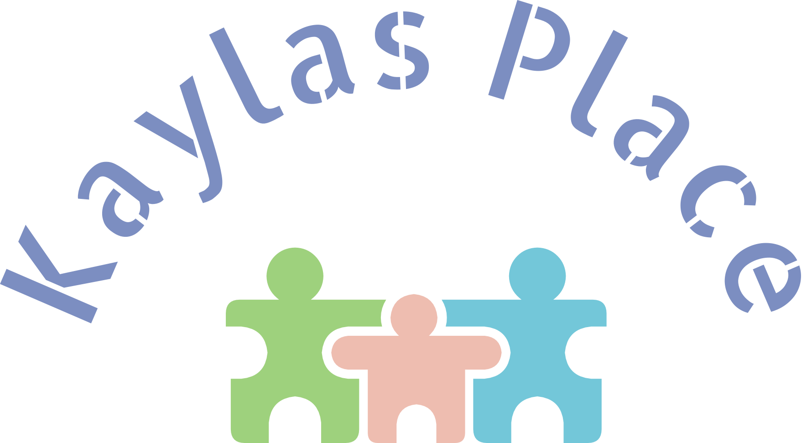

41 Sheldon Dr. Monticello, NY 12701 Phone: (845) 513-5754 Fax: (914) 292-3422 E-mail:inquiry@kaylasplace.org website: www.kspwellness.com

INTEGRATED EVALUATION SUMMARY FOR CORE EVALUATION

(ONLY)
(Please Type)

CHILD’S NAME: Sample Brown DOB: 3/24/2023 C.A.: 23/24 months
PARENTS’ NAME: Mr. and Mrs. Brown CHILD RESIDES WITH: Parents
CHILD’S RESIDES AT: 123 Love Street New Rochelle, NY 10801
HOME PHONE: (914) 123-4567

WCDH EIOD: Michelle Lugo
INITIAL / ONGOING SERVICE COORDINATOR: Magdalena Matute
^{Circle One} AGENCY: TFC
AREAS OF CONCERN: Expressive language development
HEALTH STATUS: Generally healthy
EVALUATION TYPE DATE LOCATION EVALUATOR NAME/AGENCY ASSESSMENT INSTRUMENTS

1. Developmental 3/22/2025 Home Carmen Williams, MS Ed. DAYC-2, HELP,

Kayla’s Place Clinical Observation,

Parent Interview

2. Speech/Language 3/25/2025 Home Bridget White Cevasco, MA, CCC-SLP PLS-5,

Kayla’s Place Clinical Observation,

Parent Interview

SUMMARY OF RESULTS – To include information on prior outside evaluations that is appropriate to eligibility.
COGNITIVE (curiosity and interest, early objective use, imitation, play schemes, problem solving, early concepts)
Sample is functioning in the below than average range in his cognitive domain. Ms. Brown shared that Sample enjoys playing with his balls and toy farm animals. During testing, Sample was able to provide consistent eye contact with the evaluators. He was observed to play and attend to a few activities. Sample will roll a toy car; stack a set of blocks; scribble on paper and toss a ball. Later, he placed toy farm animal pieces onto a wooden puzzle board and tap the keys on a toy piano. However, Sample had some difficulties in his cognitive domain. When asked, Sample was unable to point to any of his body parts. Mother shared that Sample, at times, will follow along to the song, “Head, Shoulders, Knees and Toes,” but outside of the song, he is unable to point to any of his body parts. Sample demonstrated a few self-directed behaviors (e.g., he did things when he wanted to and not when asked by authoritative figures). When presented with a picture book, Sample simply flipped through the pages and did not point to any common object. Although the evaluator presented him with his Mickey Mouse doll and a spoon, Sample was unable to show an understanding of pretend play. Rather than feed the doll, Sample flung the doll to the side and proceeded to play on his own. Sample did not stop to accept redirection from his mother or the evaluator. Often times, he left tasks unfinished. While working with Sample, he was not heard to use any language. Informed clinical opinion suggests a 25% delay in this area.

COMMUNICATION (expressive and receptive language levels, oral motor functioning)
Sample Brown, age 2.0 years, presents with severely delayed receptive and expressive language skills. English is his dominant language at this time. His response to his name were judged to be inconsistent. Sample received a total language standard score of 68. Expressively he was unable to speak consistently using single word utterances to label objects and pictures. Instead he produced strings of jargon, word approximations two or three single words and whined. As per the Department of Health’s Clinical Practice Guidelines, Sample presents with the following clinical clues for concern at the 18 months age level:

Does not attempt to imitate or spontaneously produce single words to convey meaning, does not persist in communication, limited comprehension of vocabulary and lack of production of vocabulary over a 6 month period.

According to the above mentioned evaluation procedures, Sample lacks basic communicative tools necessary during daily routines. Lack of these skills is negatively affecting Sample’s daily functioning as he is unable to effectively communicate his wants and needs.

SOCIAL-EMOTIONAL (relatedness, regulation of attention, behavior, and emotion)
Sample is functioning at the 20-month level in his social-emotional domain. Parents stated that Sample is affectionate and will give and accept Sample is functioning at the 20-month level in his social-emotional domain. Ms. Brown stated that Sample is affectionate and will give and accept hugs and kisses from family members. During testing, Sample was observed to share toys with the evaluator. While parents are at work, Sample attends the Little Feet Childcare Program in Somers. Reportedly, Sample attends the program Monday through Friday from 8:30am until about 4:30pm. Sample has been at the program for about a year. Mother shared that Sample will hit others if he does not get his way. She reported that Sample uses a pacifier for comfort (but only to sleep).

PHYSICAL (fine and gross motor, motor planning, regulation of sensory input)

Sample is functioning at the 24-month level in his physical domain. With respect to his gross motor domain, Sample was observed to walk around the living room and hallway areas with no difficulty. Ms. Brown stated that Sample is able to climb up and down from the sofa, adult chair and bed. Sample can pick up toys from the floor and squat while playing; and maintain his balance when he stands up. She also stated that Sample is able to go up and down a set of stairs, with supervision. With respect to his fine motor domain, Sample can scribble markings on paper. Mother reported that Sample is able to hold a spoon and fork correctly in order to feed himself.

ADAPTIVE (attachment status, self-help skills)
Sample is functioning at the 22-month level in his adaptive domain. Ms. Brown stated that Sample will drink from an open cup; and can sip from a straw. She also stated that Sample has no food sensitivities and has no concerns with his chewing or swallowing foods. Sample will eat a variety of foods, with the exception of “wet foods.” He is able to use his fingers as well as a spoon and fork to feed himself. Mother reported that Sample will nap during the day and is able to sleep through the night. Sample enjoys taking baths, splashing and playing with his toys while in the bathtub. He will accept help when it comes to getting dressed and will allow his mother to wash and comb his hair. Sample is learning to brush his teeth by himself. He has been introduced to the potty.

MUST BE COMPLETED BY EVALUATION AGENCY
THE RESULT OF THIS EVALUATION (CORE AND SUPPLEMENTAL) INDICATE THAT THIS CHILD

IS

ELIGIBLE TO RECEIVE SERVICES UNDER THE WCDH EARLY INTERVENTION PROGRAM BASED ON SDOH ELIGIBILITY CRITERIA AS PER THE ATTACHED EVALUATION DATA SHEET

SUGGESTED FUNCTIONAL OUTCOMES

FUNCTIONAL OUTCOMES ARE SKILLS THE CHILD NEEDS TO MASTER IN ORDER TO FUNCTION DURING FAMILY/COMMUNITY ROUTINES AND ACTIVITIES (PLAY, MEAL TIMES, BED TIMES, SOCIAL RELATIONSHIPS)
(NOTE: According to NYS Reg. Sec.69-4.8(a)(4)(iv) evaluators should avoid making recommendations for frequency and duration of specific services.)

COGNITIVE:
- attend and complete assigned tasks; and follow them through completion;
- point to at least 3 of his body parts on command;
- point to at least 3 common objects in a picture book upon command.

COMMUNICATION:
- Sample will spontaneously use single words.
- Sample will imitate two word phrases.
- Sample will produce two word phrases.
- Sample will follow two-step directives.

THE FOLLOWING COMMUNITY RESOURCES AND/OR SUPPORTS WOULD BENEFIT THIS CHILD AND FAMILY:

Recommendations
- Special Instruction services.
- Speech Therapy services.

COMPLETED BY: Carmen Williams, M.S. Ed TITLE: Developmental Evaluator

AGENCY: Kayla’s Place DATE: 3/22/2025

